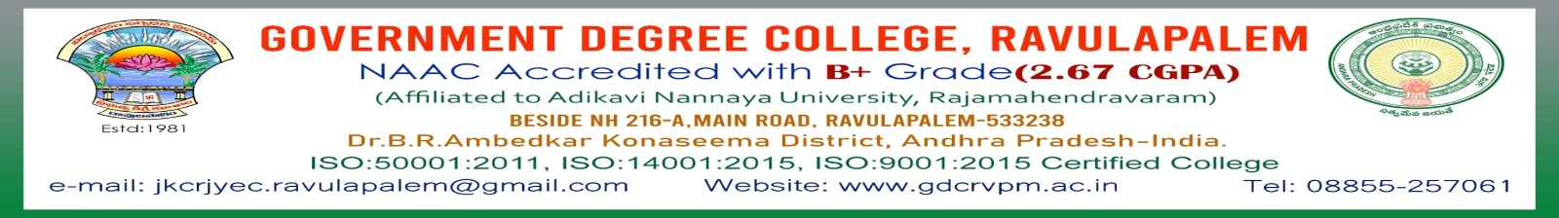

**DAPERTMENT OF POLITICAL SCIENCE**

**WORLD HUMAN RIGHTS DAY**

**10-12-2023**

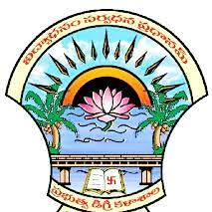

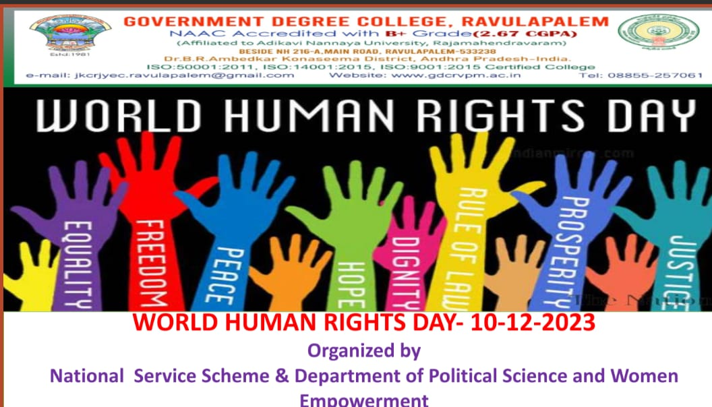

**MINUTES OF THE MEETING(06/12/2023)**

The Departments of Political Science and Wec, Govt Degree College, Ravulapalem met with the Department HOD Dr B.Haribabu garu & Smt. K Rajani to conduct International Human Rights day on December 10 th 2023.

**Members Attended:**

1.Sri.S.Chinababu (Lecturer in Economics)

2.Dr.B. Haribabu I/C of the Department

3. Sri.V.Siddhardha Kumar (Lect in History)

4. Sri.S Rajendra prasad lec in Pol. Science

**MINUTES OF THE MEETING**

Keeping in view the significance of department of Political Science and Wec proposed to celebrate International Human Rights day on December 10 th 2023 to create awareness, inculcate and inspiring the students..

.

**RESOLUTION**

It is unanimously resolved to request the principal to accord permission to conduct the International Human Rights day on December 10 th 2023 in offline mode on 10-12-2023.

Signatures:

1. Sri.S.Chinababu (Lecturer in Economics)
2. Dr.B. Haribabu I/C of the Department
3. Sri.V.Siddhardha Kumar (Lect in History)

4. Sri.S Rajendra prasad lec in Pol. Science

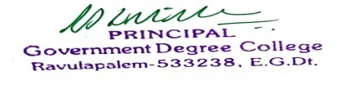

Principal

Letter to the Principal

The Principal, Dept of Pol.Science& History,

Government Degree College, Government Degree College

Ravulapalem.

**Sub** International Human Rights day on December 10 th 2021 by the Department of Political Science and Wec.

**Respected principal,**

Every year International Human Rights day on December 10 th 2021 celebrate So we the lecturers in Political Science and Wec are going to conduct International Human Rights day on December 10 th 2021.

**Thanking you sir,**

Thanking you sir,

Yours faithfully,

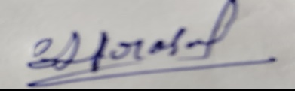

Sri S. Rajendra Prasad,

Lecturer in Political Science

**CIRCULAR**

All the staff and students are here by informed that on the occasion of International Human Rights day conduct this programme on December 10, 2023. So, all are requested to attend this programme in Mana TV room 10th December, 2023 at 11.30am and make it success.

Signatures:

1.I BA

2.II BA

3.III BA

4.I B.COM (G &CA)

5.II B.COM(G&CA)

6.III B.COM(G&CA)

7.I BSC (MPC, MPCS&IOT)

8.II BSC (MPC, MPCS&IOT)

9.III BSC (MPC, MPCS&IOT)

10.I BZC (CBZ &HBC)

11.II BZC (CBZ &HBC)

12.III BZC (CBZ &HBC)



Principal

Department of Political Science

Date & Time: 10-12-2023

Name of the Program: World Human Rights Day Resource Persons: Sri KV Sekhar, President, State Teachers

Union/Association and Smt P.Nirmala Kumari, Head Mistress, Elementary School, Vedireswaram, Ravulapalem Mandal

Brief Report: The programme was organised by the Departments of Political Science, History in association with

National Service Scheme (NSS) AND WEC of the college. Human Rights Day was celebrated on 10/12/2023 at GDC,

Ravulapalem. Vice Principal inaugurated the program by lighting the lamp and addressed the student community as a

resource person. Other resource persons explained Human Rights under the United Nations Charter. Explaining the legal

provision of Human Rights under UDHR (Universal Declaration of Human Rights) and Human Rights Act 1993, the

resource persons stressed the constitutional provisions with decided case laws where Human Rights were being violated.

